Name: … | Surname: …

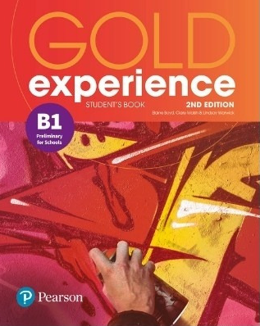
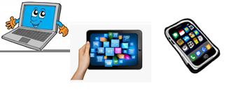
Home Schooling 43

Gold Experience B1, 2nd Edition Book (pages 86 and 84)

Travellers’ Tales | Listening

- Discuss the next questions

- What kind of things do you think you can learn when you travel to new places?
…

- Do you think you can learn the same things better in school? Why/Why not?
…

- Listen to a girl talking about how she and her family are travelling the world. Answer the questions.
Click here: https://bit.ly/3iyq6XN

- Has she enjoyed travelling? Why/Why not?
…

- Where does she go to school?
…

- Listen again and complete the sentences. Write one or two words or a number or a date or a time.
Click here: https://bit.ly/3iyq6XN

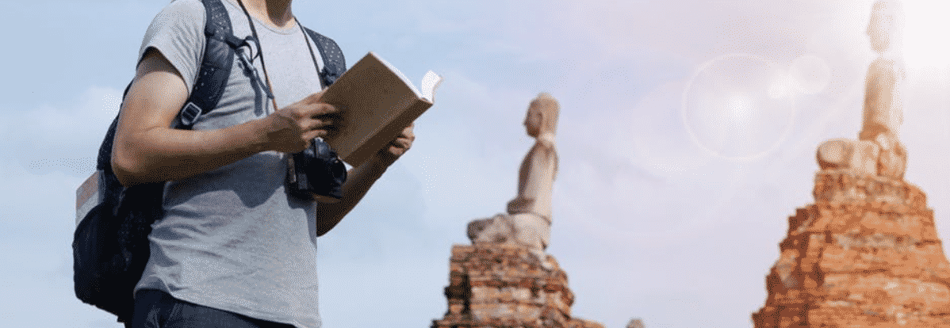
Learn while you travel
Sarah is home-schooled but travels a lot. She first started travelling at the age of ¹….
She travelled around Australia and then visited the south of ²….
She has only visited places which are ³….
She likes to read ⁴… about places she has visited.
She has had the opportunity to go walking and ⁵… in beautiful places.
The most important part for Sarah is making ⁶….

GO
ONLINE

CLICK AND WORK ONLINE:
Grammar – Defining Relative Clauses
https://forms.gle/vc6tP8Gnt4ucXyxw8

PLEASE PRESS “SUBMIT/SEND” AT THE END OF YOUR ONLINE WORK
POR FAVOR PRESIONAR “ENVIAR” AL FINAL DEL TRABAJO EN LÍNEA

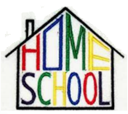
This is the end of your file. Check you have solved all the activities, save your work and send it to your teacher via email:
Ezequiel: mrlavena7th@gmail.com
Gisela: msgisela7th@gmail.com
Florencia: msflorz7th@gmail.com
Camila: mscamila7th@gmail.com

