|  |  |
| --- | --- |
| ***Name: …*** | ***Surname: …*** |

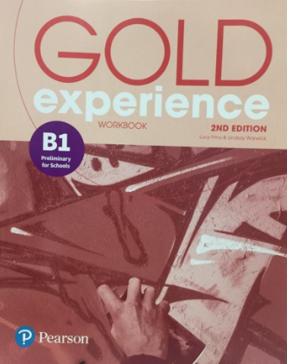***Home Schooling 44 ***

**Gold Experience B1, 2nd Edition Workbook (page 61)**



**Vocabulary: Travel**

* **Complete the conversation with the travel words in the box.**

|  |
| --- |
| **abroad flights journey motorway passport sightseeing travelling trip** |

|  |
| --- |
| **A:** Guess what! I’m going on a school **…** to Istanbul in the spring!  **B:** Really? Wow! How are you **…** there?  **A:** By coach. The **…** are too expensive.  **B:** I bet that’s a long way.  **A:** Yeah, thirty-six hours. It’ll be a really boring **…** too. We’ll be on the **…** most of the time.  **B:** Is it your first time **…**?  **A:** Yeah. We usually just go camping around here. I’ve just got my **…** out because our teacher wants to see them all.  **B:** How’s the photo?!  **A:** So embarrassing. It’s four years old. I look so young!  **B:** What are you going to do while you’re in Istanbul?  **A:** We’re going to visit a school there and, of course, we’ll go **…** to see some of the most interesting places in the city. |

**CLICK AND WORK ONLINE:**

**GO**

**ONLINE**

[**https://forms.gle/is7KEJQVDixX2sA3A**](https://forms.gle/is7KEJQVDixX2sA3A)

**PLEASE PRESS “SUBMIT/SEND” AT THE END OF YOUR ONLINE WORK**

**POR FAVOR PRESIONAR “ENVIAR” AL FINAL DEL TRABAJO EN LÍNEA**

**After working online come back to this file, to solve two more exercises.**



* **Write one or two paragraphs (about 80-100 words) describing a holiday or trip you went on. Try to use words from this lesson. Remember to use the simple past!**

|  |
| --- |
| **…** |

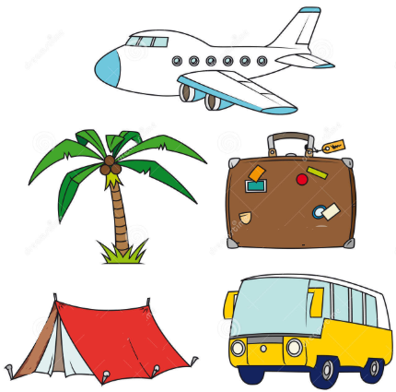

* **SKILLS 13B: You will hear a holiday representative talking to some new guests about their hotel.**

**For each gap, write one or two words, a number, a date or a time.**

**Click here:** [**https://bit.ly/33yif8l**](https://bit.ly/33yif8l)



This is the end of your file. Check you have solved all the activities, save your work and send it to your teacher via email:

Ezequiel: [mrlavena7th@gmail.com](mailto:mrlavena7th@gmail.com)

Gisela: [msgisela7th@gmail.com](mailto:msgisela7th@gmail.com)

Florencia:[msflorz7th@gmail.com](mailto:msgisela7th@gmail.com)

Camila:[mscamila7th@gmail.com](mailto:mscamila7th@gmail.com)

