Name: … Surname: …
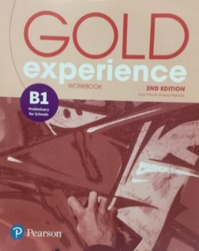
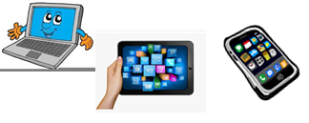Home Schooling 48

Gold Experience B1, 2nd Edition Workbook (page 64)

- Read the advert. What information should you include in your article? …

Tips for travelling around your city or town

Tell us about the different ways of getting around.
Say which is the best.
Say which is the worst.

Write an article describing these three points and we will publish the most interesting ones on our site.
Around 100 words, please!

2) Choose the best opening question for the article from Ex 1.
A Have you ever travelled to school by boat?
B How important is the tram system in your city?
C How many different ways are there to get around where you live?

3)Choose the best closing question / statement for the article from Ex 1.
A Have you got any good suggestions for places to visit?
B What would you recommend to visitors in your town or city?
C Let me know if there are more different types in your area.
4) Complete a student’s article with these adjectives.
better cheaper popular useful second-hand
Top tips for getting around Cambridge
By Louise Bower

How many different ways are there to get around your city? In Cambridge, there’s a bus network, a train service and there are plenty of taxis. However, cycling is the most 1 … form of transport.
Thousands of people travel around the city by bike every day. It’s 2 … than other forms of transport and you can avoid the traffic. It’s also 3 … for your health. You can hire a bike or you can buy a 4 … one. The train is probably the least 5 … way to get around because it takes you away from the city, not around it.
So, that’s Cambridge. What would you recommend to visitors in your town or city?
5) Read the advert from Ex 1 again and make notes to plan your article. Think about these things.
1- What title will you give your article?
2- Think of an opening question to the reader.
3- Look at your answer to Ex 1 and make notes for each point you need to include.
4- Think of a closing statement or question to the reader.

Now it is your turn!

Write your article in about 100 words

…

GO
ONLINE

CLICK AND WORK ONLINE
SKILLS 15A: https://forms.gle/CNmQiqUxRKV1rhbK6

PLEASE PRESS “SUBMIT/SEND” AT THE END OF YOUR ONLINE WORK
POR FAVOR PRESIONAR “ENVIAR” AL FINAL DEL TRABAJO EN LÍNEA
This is the end of your file. Check you have solved all the activities, save your work and send it to your teacher via email:
Ezequiel: mrlavena7th@gmail.com
Gisela: msgisela7th@gmail.com
Florencia:msflorz7th@gmail.com
Camila:mscamila7th@gmail.com

