Name:… Surname: …
Home Schooling 8 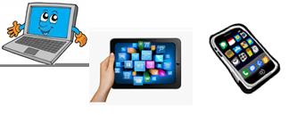

Switch On

Before watching the clip…
- Answer the following questions:

- When you were a young child, what did you want to be when you grew up? What job did you want to do?

…

- What were your favourite toys when you were younger?

…

- To watch the video, click here:
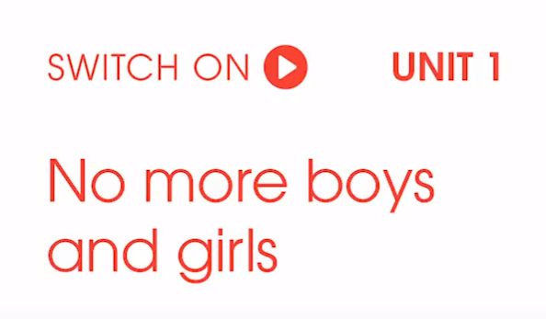
https://drive.google.com/file/d/176BHNJhGNzwMAD1dH1XzvLRKUevbM1lF/view?usp=sharing

- What’s the main thing that the children have learnt by the end of the experiment?

…

- Watch again. Are the sentences TRUE or FALSE?

- Scientists agree that boys’ and girls’ brains are different. …

- When they’re young, girls are just as strong as boys. …

- Javid gives the girls a teddy bear, and the boys a robot. …

- At the end of the experiment the boys’ behaviour is worse. …

- At the end of the experiment the girls’ self-confidence has improved. …

- Choose ONE of the points listed below and think about how it could be more gender-neutral. Write your ideas in about 80 words.

- classrooms and school environment
- classes
- school uniform
- after school activities

…

This is the end of your file. Check you have solved all the activities, save your work and send it to your teacher via email:
Ezequiel: mrlavena7th@gmail.com
Gisela: msgisela7th@gmail.com
Florencia: msflorz7th@gmail.com
Camila: mscamila7th@gmail.com

