Name: … | Surname: …

Home Schooling 9
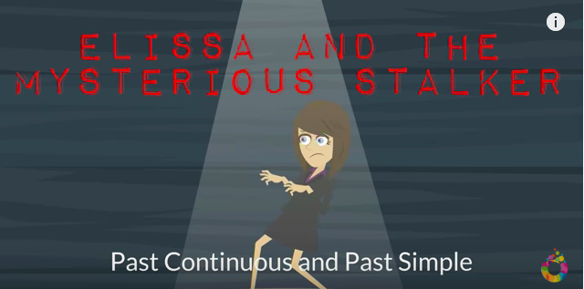

Watch the next video and take notes. You can pause it and see it as many times as you need. You can always send an e-mail to your teachers if you have questions.
https://www.youtube.com/watch?v=0_lrUe7sAAc
PAST SIMPLE
Affirmative
The past simple shows us that an action was in the past, not in the present. Regular past simple verbs have -ed at the end (e.g. called, played, arrived). Irregular verbs have a different form, usually with a different vowel sound (e.g. wake → woke, break → broke, feel → felt).

- My parents called me yesterday.
- I woke up early this morning.
- Sam played basketball when he was at university.

Now, let’s try to put this into practice. Use the past simple form of the verbs in brackets.

- My dog (sleep) … on my bed last night.
- Our English course (begin) … about a month ago.
- The students (take) … an exam yesterday.
- I (study) … for the exam and passed it!
- The baby (cry) … all night!
- The postman (check) … the address.
/6

Negative
We make the negative with didn’t and the infinitive verb.

- My parents didn’t call me yesterday.
- I didn’t wake up early this morning.

Let’s put it into practice! Read the sentences below and write the negative forms of the verbs on the red dots.

- He played handball. → He … handball.
- Susan waited in the kitchen. → Susan … in the kitchen.
- I made the beds. → I … the beds.
- They cleaned the classroom. → They … the classroom.
- She asked a lot of questions. → She … a lot of questions.
/5

Questions
We make short questions with did and then the subject and infinitive verb.

DID + SUBJECT + VERB IN THE INFINITIVE?

- Did you wake up early this morning?
- Did Sam play basketball when he was at university?

You can also make longer questions as we can see below.

WH- + DID + SUBJECT + VERB IN THE INFINITIVE?

- Where did they go after the match?
- When did she meet her boyfriend?
- What did you play yesterday evening?

Make Past Simple questions
SHORT QUESTIONS
- … (I/see) you last week?
- … (you/meet) your father yesterday?
- … (we/go) to Spain last January?
- … (it/snow) last winter?
LONG QUESTIONS
- Where … (you/go) last weekend?
- When … (she/arrive)?
- Why … (he/eat) so much?
- What … (they/do) yesterday?
/8
PAST CONTINUOUS
Affirmative
The Past continuous shows us that the action was already in progress at a certain time in the past.

- What were you doing at 8 p.m. last night? I was studying.
The past continuous can also show that an activity was in progress for some time, not just for a moment.

- We were cleaning the house all morning.
We make the past continuous with was or were and the -ing form of the verb.

Put the verbs into the correct form in the Past Continuous

- When I phoned my friends, they (play) … monopoly.
- Yesterday at six I (prepare) … dinner.
- The kids (play) … in the garden when it suddenly began to rain.
- I (practise) … the guitar when he came home.
- We (not / cycle) … all day.
- While Aaron (work) … in his room, his friends (swim) … in the pool.
/6
Negative
We make the negative with was/were and the verb + -ing.

- I wasn’t working.
- You weren’t reading.
- Pierre wasn’t teaching.
Write negative sentences in past progressive.
- Sarah and Luke / not / work. …
- Mister Miller / not / teach / chemistry. …
- Barry / not / drive / a lorry. …
- Mandy / not / have / lunch. …
- Albert / not / play / tennis. …
- Taylor and Bob / not / cycle / home. …
/6
Questions
We make short questions with was/were and then the subject and verb + -ing.
WAS/WERE + SUBJECT + VERB + -ING?

You can also make longer questions as we can see below.

WH- + WAS/WERE + SUBJECT + VERB + -ING?

Make questions in the Past Continuous
YES-NO QUESTIONS

- … the museum? (she/visit)
- … with a pencil? (you/write)
- … comics? (the boys/read)
- … questions? (Kimberly/ask)
/4

WH QUESTIONS

- Why … I … (work)?
- Where … you … (live)?
- How … she … (travel)?
- Where … he … (go)?
- Who … she … (talking) to?
/5
Put the verbs in brackets into the correct form, past simple or past continuous.
ISSAC’S STORY
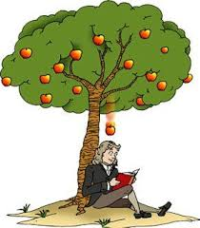
The sun 1 … (shine) and the birds 2 … (sing), so Isaac 3 … (decide) to go outside. While he 4 … (sit) in his garden, he 5 … (start) to look at an apple tree. While he 6 … (watch) the tree, an apple 7 … (fall) from the tree and 8 … (land) on the ground. While he 9 … (look) at the apple, he asked himself a question: why 10 … (fall) the apple down and not go up? As he 11 … (think) about this question, he 12 … (have) an idea: maybe the Earth pulls the apple towards it.
This 13 ... (happen) more than 300 years ago, and Issac is still famous today. Do you know his full name? Do you know what he 14 … (discover) while he 15 … (sit) in the garden?
The theory of …

/15

File score: /55

This is the end of your file. Check you have solved all the activities, save your work and send it to your teacher via email:
Ezequiel: mrlavena7th@gmail.com
Gisela: msgisela7th@gmail.com
Florencia: msflorz7th@gmail.com
Camila: mscamila7th@gmail.com

