Name: … Surname: …
Home Schooling 32
1 Complete the notices (1-8) with these words
changing rooms coach court locker match prize race track
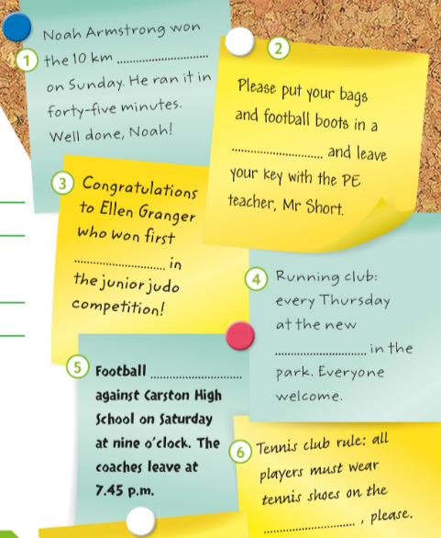
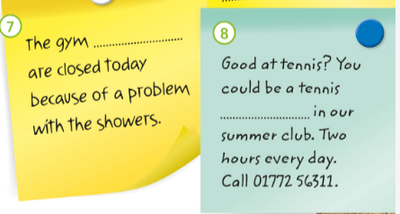
1 | …
2 | …
3 | …
4 | …
5 | …
6 | …
7 | …
8 | …

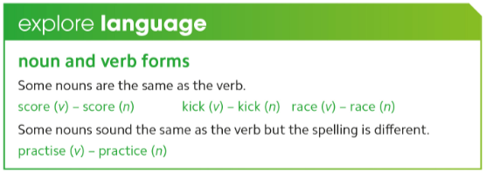
GO
ONLINE

CLICK AND WORK ONLINE:
https://forms.gle/v2jiM65VQz7fNxiw9
Skills 9: https://forms.gle/TiLqgg4nY64YmJRy5

After working online, come back to this file to solve the following exercise

2-Listen and fill in the gaps with a phrase, a number or a date.
Before you listen, read the tips for each gap. Click to listen: https://bit.ly/2BXvNOF
Mini Olympic Games
Location: Greenford Primary School
Closing date for entries: 1. …
Aims: *to raise money for research and a new 2. …
*to encourage children in sport.
First event starts: 3. …
Parents make sure that children have enough 4. … on the day.
Most popular event expected to be 5. … .
More children needed for the 6. … event.

Gap 1: you will hear many dates, just keep the last date you can apply to take part. part.

Gap 2: the words in the recording are not exactly the words you need but they have the same meaning.

Gap 3: listen for a time. You will hear three different times, listen for the correct one.
meaning.

Gap 4: one thing is provided but parents have to bring something themselves.

Gap 5: You will hear about different events. Listen for another way of saying “most popular.”

Gap 6: Listen for the event that doesn’t have enough people yet.

This is the end of your file. Check you have solved all the activities, save your work and send it to your teacher via email:
Ezequiel: mrlavena7th@gmail.com
Gisela: msgisela7th@gmail.com
Florencia: msflorz7th@gmail.com
Camila: mscamila7th@gmail.com

