Name: … Surname: …
Home Schooling 33
GO
ONLINE

CLICK AND WORK ONLINE:
https://forms.gle/FCMh78hKn7WAdHySA

PLEASE PRESS “SUBMIT/SEND” AT THE END OF YOUR ONLINE WORK
POR FAVOR PRESIONAR “ENVIAR” AL FINAL DEL TRABAJO EN LÍNEA
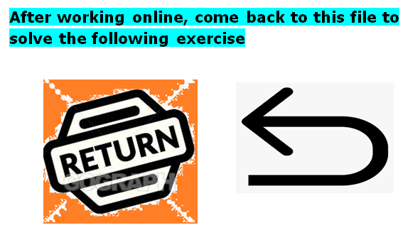

1- Listen to an interview with a young man who loves football. Complete the notes with one word in each gap.
Click to listen: https://bit.ly/2YooEQx
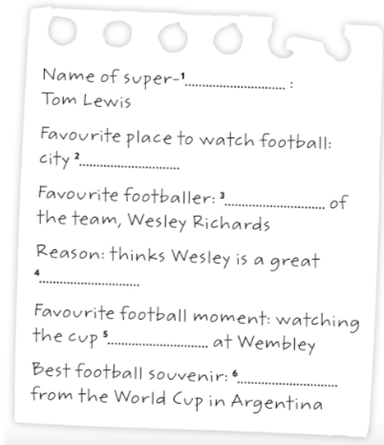
1. …
2. …
3. …
4. …
5. …
6. …

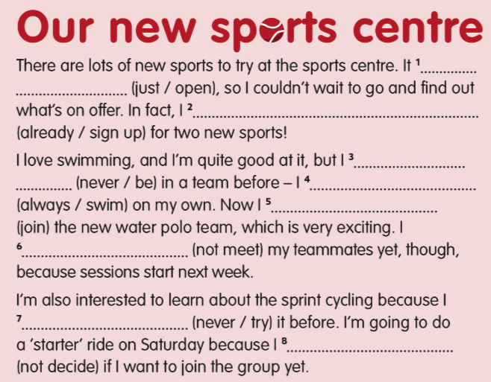
2- Complete the blog post with the present perfect form of the verbs in brackets.
1 | …
2 | …
3 | …
4 | …
5 | …
6 | …
7 | …
8 | …

This is the end of your file. Check you have solved all the activities, save your work and send it to your teacher via email:
Ezequiel: mrlavena7th@gmail.com
Gisela: msgisela7th@gmail.com
Florencia: msflorz7th@gmail.com
Camila: mscamila7th@gmail.com

