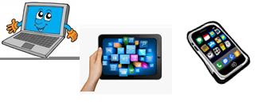  Name: … | Surname: …
Home Schooling 36

Writing

1-Do you do any of these sports? Write your sports in the correct column in the table. Do you do any other activities that you can add?

basketball cycling football rugby running tennis volleyball hockey

At school | With my family | With my friends | I don’t do these sports
… | … | … | …

2-Read the advert. What does it invite students to write?
What is the prize?
…

Sports FANS

We want to know about a sport you have tried.

- Why were you doing this sport?
- What happened when you tried it?
- Did you enjoy it and have you continued doing it in your free time?

We will send some sports equipment to the writer of the best article!

3-Read Jessica’s article for the previous advert. Match the ideas (A–C) with the paragraphs (1–3).

- details of what happened when Jessica tried the sport …
- an explanation of why Jessica was doing the sport …
- information about if Jessica enjoyed the sport and has continued doing it …

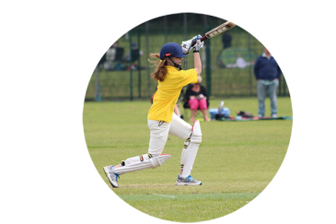
A new sport
by Jessica, 16
1 I’ve done lots of different sports. Last summer my cousin suggested trying cricket together, so we joined the local cricket club.
2 We divided into teams and played against each other. As soon as I hit the ball for the first time, I realised it was quite hard to play. You spend a lot of time on your feet and you need to concentrate. Although I’m not sure I was very good at it, I had a great time playing!
3 I haven’t played cricket since last summer but I did enjoy it, so now I’m watching videos to find out how to play better so that I can play again next summer!

Does she respond to all the questions asked in the advert? …

NOW GO
ONLINE

CLICK AND WORK ONLINE:

https://forms.gle/BYE767uKJKt9fN8w7

PLEASE PRESS “SUBMIT/SEND” AT THE END OF YOUR ONLINE WORK
POR FAVOR PRESIONAR “ENVIAR” AL FINAL DEL TRABAJO EN LÍNEA
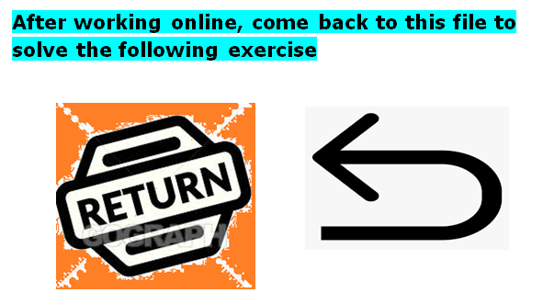
7-Read the advert again. Decide which sport or activity you will write about. Complete the notes with your ideas.
Name of sport and why I was doing it
…
What happened
…
Did I enjoy, etc.?

…

8-Now, write your article in about 100 words. Include all the information you used to answer the questions in the previous exercise.

A sport I have tried…

…

CHECK

- Spelling mistakes
- Tenses
- Vocabulary
- Punctuations marks
- Capital letters

NOW GO
ONLINE AGAIN

CLICK AND WORK ONLINE:

Skills 11A: https://forms.gle/cjxg2BLoLQrrXHm1A

PLEASE PRESS “SUBMIT/SEND” AT THE END OF YOUR ONLINE WORK
POR FAVOR PRESIONAR “ENVIAR” AL FINAL DEL TRABAJO EN LÍNEA

This is the end of your file. Check you have solved all the activities, save your work and send it to your teacher via email:
Ezequiel: mrlavena7th@gmail.com
Gisela: msgisela7th@gmail.com
Florencia: msflorz7th@gmail.com
Camila: mscamila7th@gmail.com

