Name: Surname:
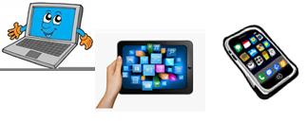
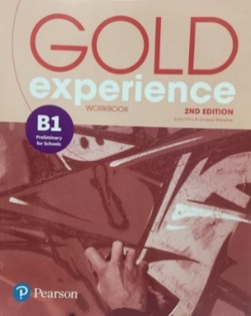
Home Schooling 51

Gold Experience B1, 2nd Edition Workbook (page 65)

1 Complete the sentences with relative pronouns. Sometimes more than one answer is possible. If a pronoun is not necessary, write it between brackets. For example: (that)

1 Do you remember the girl … sat next to us on the plane?
2 The city … I want to visit the most is Buenos Aires.
3 We’re travelling on the train … goes to Dublin.
4 The people … work here are nice and very friendly.
5 Where are the tickets … I gave you this morning?
6 There was a long delay at the airport … made people angry.
7 The place … I love the most is definitely Venice.
8 I love places … I can have fun.

2 Complete the words in the blog post. The first and the last letters are given. Write the word on the red dots in brackets (…)

Last year my family and I went on a ¹c _ _ _ _ e (…) around the Mediterranean on a huge ship. It was like a city! We took a ²f_ _ _ _t (…) from London to Barcelona and got on the ship there. There were five different ³d _ _ _ _ _ _ _ _ _ _ s (…) over the week, including Naples and Rome. We didn’t ⁴h _ _ e (…) to get off the ship in each place but, of course, we wanted to do some ⁵s _ _ _ _ _ _ _ _ _ g (…). We ⁶h _ d (…) to be back on the ship by a certain time, though, or we could be left behind. In Rome, we paid a ⁷g _ _ _ e (…) to show us around the main sights. It´s such a beautiful city! The only problem was the ⁸t _ _ _ _ _ c (…) jams on most of the roads, ⁹w _ _ _ h (…) made it difficult to get to all the places we wanted to see.
But the best thing about the trip was the food. The holiday was ¹⁰full-b _ _ _ d (…), so there was food to eat all day. And eat we did!

3 Put the letters in the correct order to make travel words. Find the hidden message

 | nald | l | a ⁴ | n | d
1 | eadyl | d | ₃
2 | dabora |  |  | ¹⁰ | o |  | 8
3 | nyurejo |  | 6
4 | rotsapsp | p |  |  |  | 12 | 7
5 | hietngesgis | s | 11 |  | 1 | 9 | s |  |  |  |  | 5
6 | sitnitenado | d |  |  |  |  |  | 2 |  |  |  | n

V
1 2 3 4 5 6 7 8 9 10 11 12

GO ONLINE

HS 51A- CLICK AND WORK ONLINE:
https://forms.gle/xcQSTCyACbtYEAZKA
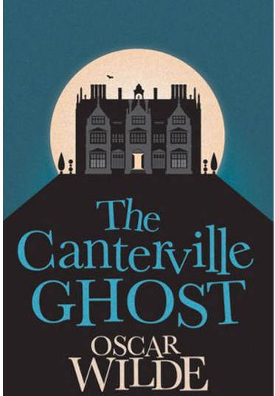
CTRL + CLICK to read and listen:
Part 1: https://bit.ly/32h3Pa3

HS 51B- CLICK AND WORK ONLINE:
https://forms.gle/H7nEwRWFG8TKXsit8
PLEASE PRESS “SUBMIT/SEND” AT THE END OF YOUR ONLINE WORK
POR FAVOR PRESIONAR “ENVIAR” AL FINAL DEL TRABAJO EN LÍNEA
This is the end of your file. Check you have solved all the activities, save your work and send it to your teacher via email:
Ezequiel: mrlavena7th@gmail.com
Gisela: msgisela7th@gmail.com
Florencia:msflorz7th@gmail.com
Camila:mscamila7th@gmail.com

