Name: … | Surname: …
Home Schooling 53

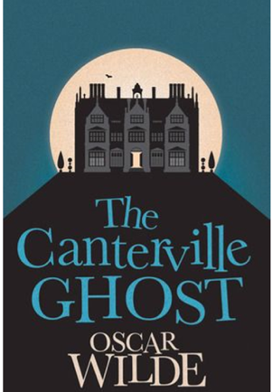

PART 1
You can watch Part 1 again at: https://bit.ly/32h3Pa3
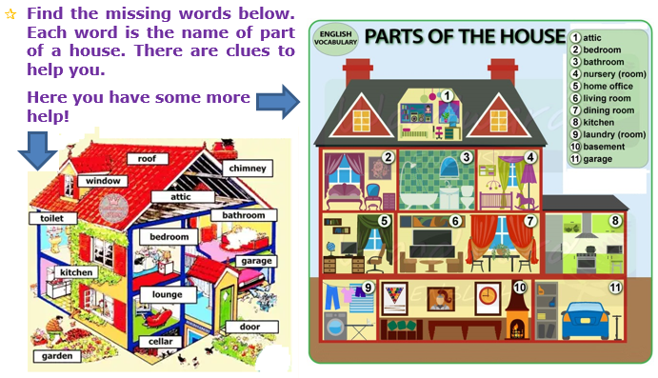

Definition | Clue | Word
You go up and down these | _ T _ _ _ _ | (…)
This is the first room in the house | _ ALL | (…)
You sleep in this room | _ _ _ _ _ _ _ | (…)
You cook in this room | _ _ _ _ _ _ _ | (…)
This room is full of books | L _ _ _ _ _ _ | (…)
Babies sleep here | N _ _ _ _ R Y | (…)
You eat dinner here | _ _ _ _ _ _ R _ _ _ | (…)
This room is at the top | A _ _ _ _ | (…)
This room is underground | C _ _ _ _ _ | (…)
This is long and narrow | CORR_ _ _ _ | (…)
You can wash in this room | _ _ _ _ _ _ _ _ | (…)
You can relax in this room | L _ _ _ _ _ _ _ _ _ | (…)
This is another name for ‘living room’ | L _ _ _ GE | (…)
The horses live here | _ _ _ _LE | (…)
This is usually the smallest room | TO_ _ _ _ | (…)

- Your friends, the twins, have just moved to another country. Now you are writing them an email. Ask them questions about the country and write about your feelings now they have gone. Finish the letter, using about 100 words.
Write your letter here

Dear friends,
How are you? Do you enjoy living in …?

CLICK AND WORK ONLINE:
GO
ONLINE
Gold Experience B1, 2nd Edition Book (pages 106, 107 and 109)

HS 53 A: Reading
https://forms.gle/DF125rrv8pommdM5A
HS 53 B: Vocabulary
https://forms.gle/MERehf1ZcZhzhwpx9

PLEASE PRESS “SUBMIT/SEND” AT THE END OF YOUR ONLINE WORK
POR FAVOR PRESIONAR “ENVIAR” AL FINAL DEL TRABAJO EN LÍNEA

This is the end of your file. Check you have solved all the activities, save your work and send it to your teacher via email:
Ezequiel: mrlavena7th@gmail.com
Gisela: msgisela7th@gmail.com
Florencia: msflorz7th@gmail.com
Camila: mscamila7th@gmail.com

