Name: Surname:

Home Schooling 62

Gold Experience B1, 2nd Edition Workbook – Unit Check (page 81)

1 Complete the sentences with the past perfect form of the verb in brackets.

1 I … (not swim) in the sea until I went to Mallorca.
2 The lesson … (just/start) when we arrived.
3 We … (not write) a shopping list before we went to the market.
4 My dad came to meet me after he … (finish) work.
5 Their train … (already/leave), so we couldn’t wave ‘goodbye’.
6 Until she saw the audience, she … (not feel) nervous.

2 Complete the text with the past perfect or past simple form of the verbs in brackets.
When I got home yesterday Mum 1 … (be) very stressed. The oven 2 … (break) and she 3 … (invite) friends around for dinner. I 4 … (say) I would help but she 5 … (tell) me to go and do my homework. I 6 … (explain) that luckily the teacher 7 … (not give) us any homework! Together we 8 … (make) a delicious dinner using the barbecue and the microwave – we 9 … (almost/finish) when her friends 10 … (arrived). Everything was OK!

3 Grace wants to find out about her grandmother’s childhood. Write her questions. Use the correct form of used to.

1 where / live?
…
2 walk / to school?
…
3 what sports / play?
…
4 where / go / after school?
…
5 have / a lot of homework?
…
6 what / enjoy / studying at school?
…

4 Grace’s grandmother is answering her questions. Complete what she says with the correct form of used to and the verbs in brackets.

We 1 … (live) in a very small cottage near the sea. There were four of us children, so we 2 … (share) a room. But we 3 … (not mind). We had a lot of fun.
We 4 … (catch) the bus to school because there wasn’t a school in the village in those days. After school we 5 … (go) down to the beach and do some fishing or go swimming in the summer. Sometimes we played football, too. We 6 … (not watch) TV or play computer games like you do. We 7 … (not have) as much homework as you children do nowadays, though. I remember I 8 … (like) science best at school. Maybe that’s why I became a chemistry teacher!

GO
ONLINE
HS 62 A: https://forms.gle/PRrhjvUJNPC4py1h9
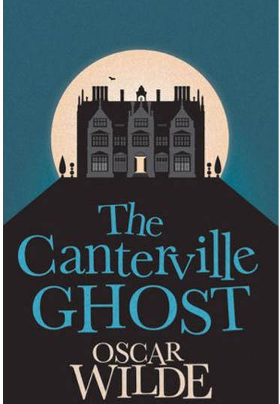
Part 4: CTRL + CLICK: https://forms.gle/ag8X2cWFZPnqXSE59

PLEASE PRESS “SUBMIT/SEND” AT THE END OF YOUR ONLINE WORK
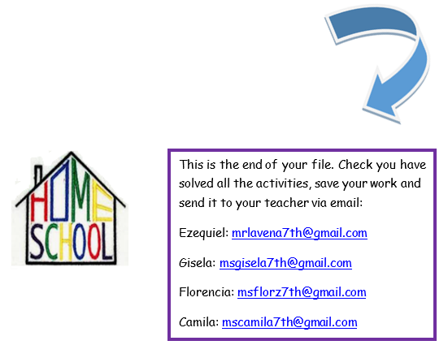
POR FAVOR PRESIONAR “ENVIAR” AL FINAL DEL TRABAJO EN LÍNEA

