Name: Surname:

Home Schooling 64

Gold Experience B1, 2nd Edition Book (page 114)
Switch on
GO
ONLINE
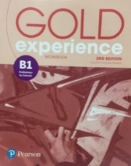
Gold Experience B1, 2nd Edition Workbook (page 80) Writing

CTRL + CLICK: HS 64A: https://forms.gle/SM9yz25UNGcUz35n7

After working online, come back to this file to solve the following exercise

- Now, write Eric’s story in about 100 words. Use the events to sorted out into beginning (B), middle (M) and end (E) on the online form and words and phrases to order the events in the story (first, next, then, suddenly, finally).

…

GO
ONLINE AGAIN
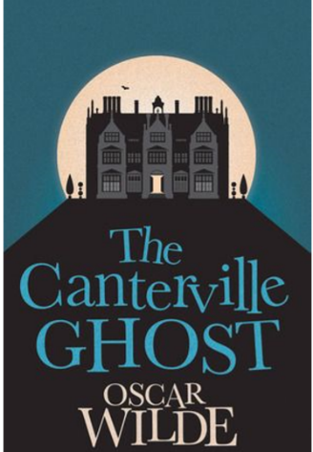

HS 64 B- Part 5: CTRL + CLICK:
https://forms.gle/gHXArUm1un21bp73A
PLEASE PRESS “SUBMIT/SEND” AT THE END OF YOUR ONLINE WORK
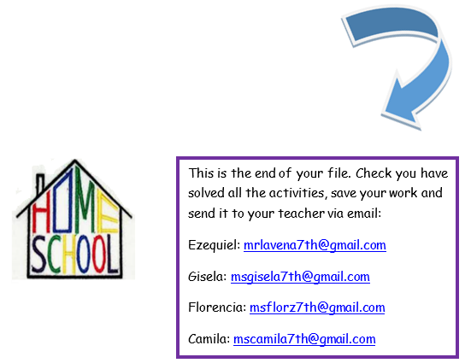
POR FAVOR PRESIONAR “ENVIAR” AL FINAL DEL TRABAJO EN LÍNEA

