Name: Surname:
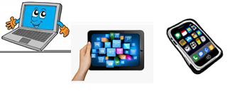
Home Schooling 67

Hobbies and interests
https://matchthememory.com/Eke

http://www.eslgamesworld.com/members/games/vocabulary/memoryaudio/hobbies/index.html

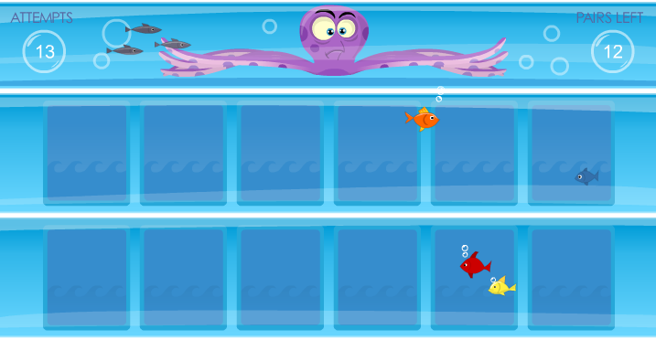
Listening: Listen and complete the gaps.
CLICK TO LISTEN: https://bit.ly/3egZwRH

- Jon is from … .
- … is mad about basketball.
- Lucy is … than Tim at basketball.
- … is into tennis.
- Darwin is in the … of Australia.
- Darwin is … than Sydney but people are … .
- Darwin is a … city; there are a lot of new … there.
- Jon is into … .

Correct the mistake
https://bit.ly/3kPwqeW

WHEN YOU FINISH CLICK ON
“FINISH” AND THEN ON “CHECK MY ANSWERS”

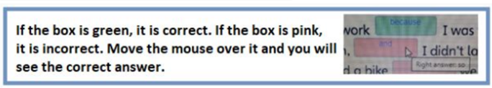

SKILLS 21A: https://forms.gle/sCMsJ6psnSZCopuw6
PLEASE PRESS “SUBMIT/SEND” AT THE END OF YOUR ONLINE WORK
POR FAVOR PRESIONAR “ENVIAR” AL FINAL DEL TRABAJO EN LÍNEA

