Name: … Surname: …
Home Schooling 69

Reported Speech: Statements

Watch this video for a detailed explanation:
https://youtu.be/dF_-Qai6ZbI
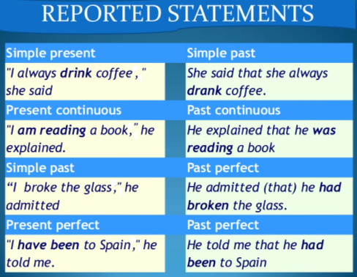

Let’s practise now:

Activity 1
CTRL + CLICK:
https://www.englisch-hilfen.de/en/exercises/reported_speech/statements2.htm

Activity 2
CTRL + CLICK:
https://elt.oup.com/student/solutions/int/grammar/grammar_06_012e?cc=global&selLanguage=en

Activity 3
CTRL + CLICK:
https://bit.ly/36aR9DA

WHEN YOU FINISH CLICK ON
“FINISH” AND THEN ON “CHECK MY ANSWERS”

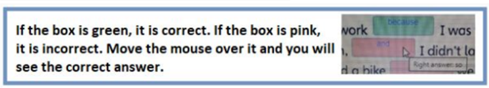

SKILLS 21B:
You will hear a man talking to a group of people about the riding holidays he organizes.
For each numbered gap, fill in the missing information.

Press ctrl and click to listen to the audio file:
https://bit.ly/32j0qsb
HORSE RIDING HOLIDAYS

Daily Programme
10 a.m.: help get the horse ready, check (1) …
11:30 a.m.: ride begins
12 p.m.: stop near (2) … or lake
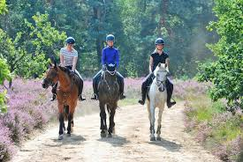
4 p.m.: arrive back at Centre

Things to take
- strong shoes or boots
- warm clothes
- swimming costume
- small bag to hold (3) …

Accommodation
- Double rooms with bathrooms
- Television room
- (4) … room
- Children’s areas

Local Attractions
- Golf
- Fishing
- Good (5) … near Centre

Price
4-day holiday costs (6) … per person

This is the end of your file. Check you have solved all the activities, save your work and send it to your teacher via email:
Ezequiel: mrlavena7th@gmail.com
Gisela: msgisela7th@gmail.com
Florencia:msflorz7th@gmail.com
Camila:mscamila7th@gmail.com

