Name: … Surname: …
Home Schooling 71

Let’s Revise!

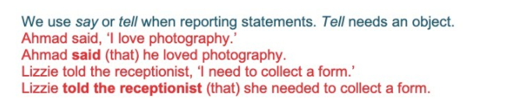

Activity 1: Game
CTRL + CLICK:
https://www.turacogames.com/games/reported-speech-grammar-game-for-esl/

Activity 2
CTRL + CLICK:
https://www.learnenglishfeelgood.com/reported-speech-mixed3.html

Activity 3
CTRL + CLICK:
https://www.englisch-hilfen.de/en/exercises/reported_speech/questions.htm

Activity 4
CTRL + CLICK: Matching
https://www.passporttoenglish.com/Advanced-English/Lesson11/Game.html
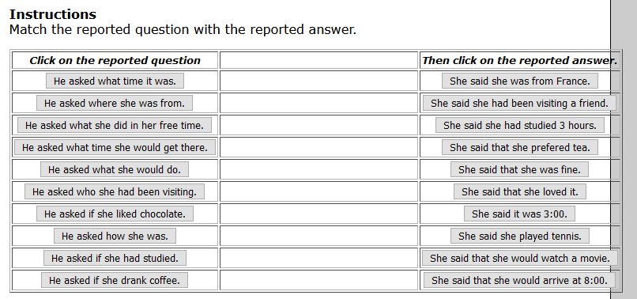

So… can you complete the dialogue now?

A: Hi! How are you?
B: … fine.
A: What time is it?
B: It’s 3.
A: …
B: … France.
A: … in your free time?
B: I play tennis. In fact, today I’m going to the club to have tennis lessons.
A: What time …?
B: … When I finish my class, at about 9 pm, I will go home.
A: …
B: I will watch a movie. This week I have been visiting someone, who is in hospital, and I want to relax when I get home.
A: Who … ?
B: …
A: Oh, I see. Do you like chocolate?
B: … . Yesterday I ate a lot of chocolate because I was nervous about next week’s maths exam.
A: …
B: …
A: …
B: I prefer tea.

SKILLS 22: https://forms.gle/LBqKLRXiZ2cLbB8A6
PLEASE PRESS “SUBMIT/SEND” AT THE END OF YOUR ONLINE WORK
POR FAVOR PRESIONAR “ENVIAR” AL FINAL DEL TRABAJO EN LÍNEA

This is the end of your file. Check you have solved all the activities, save your work and send it to your teacher via email:
Ezequiel: mrlavena7th@gmail.com
Gisela: msgisela7th@gmail.com
Florencia:msflorz7th@gmail.com
Camila:mscamila7th@gmail.com

