Name: … Surname: …

Home Schooling 72
Reported commands
CTRL + click on the link to watch a detail explanation:
https://bit.ly/3fgKpsd
Now read attentively:
What people say | Reporting what people said
“ Stand up!” | The teacher told them to stand up.
“ Be quiet!” | He told the child to be quiet
“Don’t touch anything.” | The mother told her son not to touch anything.
“Don’t worry.” | Mary told her friend not to worry

1 Rewrite the instructions as a reported command. Number 1 is an example.
1

She told her brother to turn the music down.
2

The dentist told the boy …
3

Charlie’s mum told him …
4

Chloe’s family told her …
2 Turn the following commands into reported speech

1 ‘Don’t forget to make your bed,’ Mum said to Ann.
…
2 ‘Put your hands up!’ the policeman said to them.
…
3 ‘Don’t make so much noise,’ my brother said to me.
…
4 ‘Pass me the ball!’ Messi said to Lautaro Martinez
…
5 ‘Study for the test!’ The teacher said to the students.
…
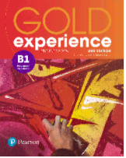

Gold Experience B1, 2nd Edition Book (pages 100 & 101)
WRITING
GO
ONLINE

SOLVE THE QUIZ:
https://forms.gle/NXCCu4AomExoSNaRA
PLEASE PRESS “SUBMIT/SEND” AT THE END OF YOUR ONLINE WORK
POR FAVOR PRESIONAR “ENVIAR” AL FINAL DEL TRABAJO EN LÍNEA

After working online, come back to this file to solve the following exercises

- Read the useful language box below.
Useful language: adjectives and adverbs
You might be surprised / amused / amazed to learn that …
I think a good / interesting / weird hobby is …
X’s hobby is great / fantastic / helpful because it’s …
She once / famously / publicly said that …

- Then read the article about a celebrity with an unusual hobby. Find at least two adjectives and two adverbs and write them below.

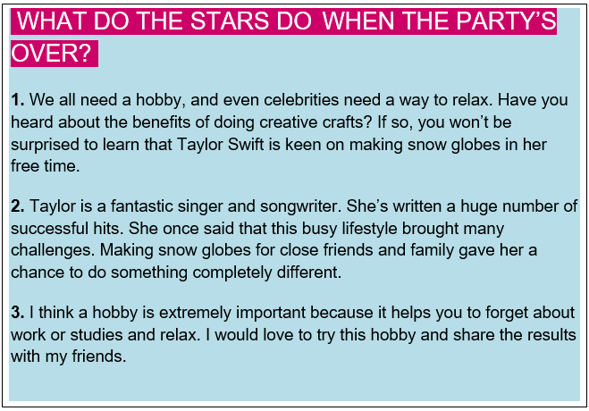
…

- Read the article again. In which paragraph (1-3) does the writer do these things?

- introduce the hobby …
- say why the person likes the hobby …
- introduce the person with the hobby …
- say why this hobby is good …

Time to write!
- Look at the following advert.
‘Activity News’
Do you know someone with an interesting or unusual hobby? Why do you think they do that hobby?
Explain whether you’d like to do this hobby or not.
Write a text for our magazine. We’ll put the best ones in next week’s issue.

- Now, think of a person you know who has an interesting hobby. Write your notes:

- introduce the hobby …
- say why the person likes the hobby …
- introduce the person with the hobby …
- say why this hobby is good …

Now, write your text in about 100 words. Use your notes.
…

