Name: … Surname: …
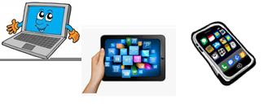
Home Schooling 73

How good are you at Reported Speech?

Activity 1: CTRL + CLICK: https://bit.ly/3m3kmrb

Activity 2: CTRL + CLICK: https://bit.ly/3lTvMxA

Activity 3: CTRL + CLICK: https://bit.ly/3kJ9OvK

Activity 4: CTRL + CLICK: https://bit.ly/3pKFGUp

SKILLS 23A: https://forms.gle/G1PqwxaXSysKD7V38
PLEASE PRESS “SUBMIT/SEND” AT THE END OF YOUR ONLINE WORK
POR FAVOR PRESIONAR “ENVIAR” AL FINAL DEL TRABAJO EN LÍNEA

