Name: … Surname: …
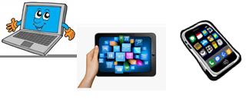
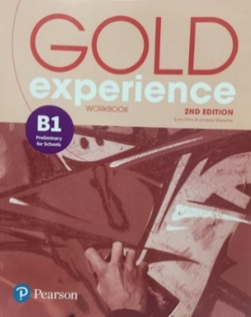
Home Schooling 74
GO ONLINE

CLICK AND WORK ONLINE:

Gold Experience B1, 2nd Edition Workbook (page 70)
LISTENING
HS 74 A: https://forms.gle/iErHssp2NMqpgXa36
Gold Experience B1, 2nd Edition Workbook (page 66)
READING
HS 74 B: https://forms.gle/1YCGUSaRVHhakUHD6
PLEASE PRESS “SUBMIT/SEND” AT THE END OF YOUR ONLINE WORK
POR FAVOR PRESIONAR “ENVIAR” AL FINAL DEL TRABAJO EN LÍNEA

