Name: … Surname: …
Home Schooling 75
Final Review
Activity 1: Game: Let’s play and revise tenses!
https://www.eslgamesplus.com/verb-tenses-interactive-grammar-game-for-esl-jeopardy-quiz-game/

More tense practice!
(easy)
https://agendaweb.org/exercises/verbs/mixed-tenses/test-2 (more difficult)
https://es.liveworksheets.com/worksheets/en/English_as_a_Second_Language_(ESL)/Verb_tenses/TENSES__REVISION_1_fv151745ye

Activity 2: Reported Speech:
a)
https://www.ego4u.com/en/cram-up/grammar/reported-speech/exercises?10

b)
https://www.ego4u.com/en/cram-up/grammar/reported-speech/exercises?11

Activity 3: Relative clauses. Who is it?
https://www.mes-games.com/parttime1.php

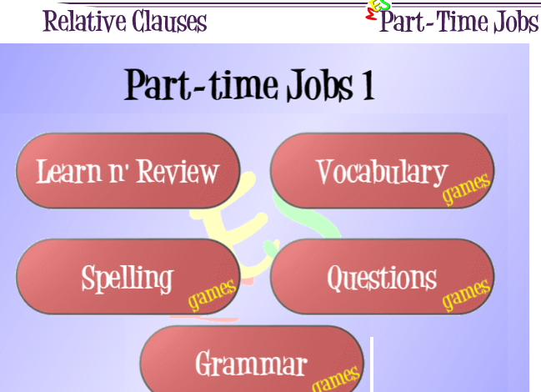
Click on “Grammar”, then on “Pirate Challenge”

Activity 4: Connectors: Expressing contrast
https://test-english.com/grammar-points/a2/however-although-time-connectors/

SKILLS 23B:
You will hear a woman talking to a group of young people about a youth club she helps to organize.
For each numbered gap, fill in the missing information.

Press ctrl and click to listen to the audio file:
https://bit.ly/378tUeb
Full-time youth worker: Caroline
More than 200 members in two sections, open to people aged from 8 to (1) …
Open: Monday – Friday evenings and all day during weekends and school holidays.
Sports activities: (2) … team has just won a competition
Art activities: (3) … is the most popular
Outdoor activities: next activity is (4) … in Lake District
date: last weekend of (5) …
Cost: £65 including accommodation, food and transport by (6) …

