Name: … | Surname: …
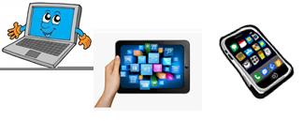
Home Schooling 35
GO
ONLINE

CLICK AND WORK ONLINE:

READING: https://forms.gle/62VUd1LCDqgsg3sW8

LISTENING: https://forms.gle/VJpkxtKCXfBhGMsp7

PLEASE PRESS “SUBMIT/SEND” AT THE END OF YOUR ONLINE WORK (POR FAVOR PRESIONAR “ENVIAR” AL FINAL DEL TRABAJO EN LINEA)

This is the end of your file. Check you have solved all the activities, save your work and send it to your teacher via email:
Ezequiel: mrlavena7th@gmail.com
Gisela: msgisela7th@gmail.com
Florencia: msflorz7th@gmail.com
Camila: mscamila7th@gmail.com

