Name: Surname:
Home Schooling 60

PAST PERFECT BASKETBALL GAME:
CLICK TO PLAY: https://bit.ly/3jpCgmk

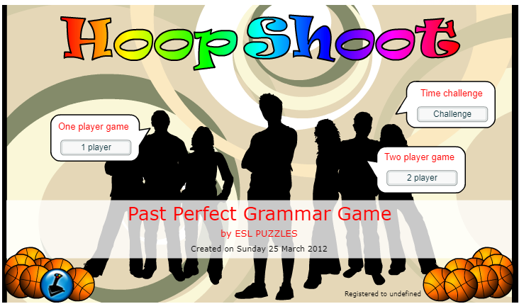

Do you like adventure?
Take part in this racing game!
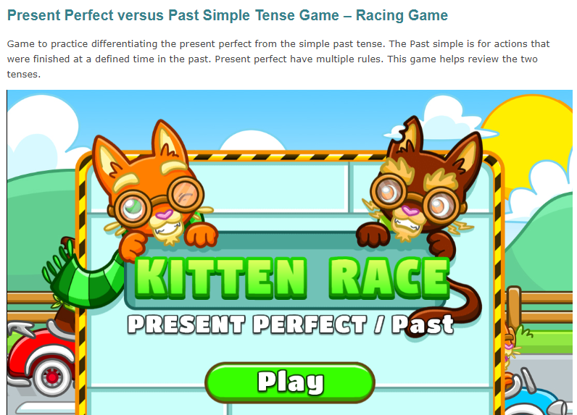
CLICK TO PLAY!
https://www.eslgamesplus.com/present-perfect-vs-past-tenses-rally/

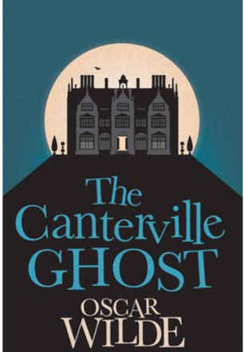
CHAPTER 3 REVISION
CTRL + CLICK to read and listen to Part 3 again: https://bit.ly/2FF4E4Y

Now answer:
- Who is the ghost’s favorite member of the family? Why?
…
- What did Mr. and Mrs. Otis do with the old paintings?
…
- What did the ghost promise after Washington’s joke?
…

SKILLS 19A: https://forms.gle/RiZN4FwLj1DQx7YD6

PLEASE PRESS “SUBMIT/SEND” AT THE END OF YOUR ONLINE WORK
POR FAVOR PRESIONAR “ENVIAR” AL FINAL DEL TRABAJO EN LÍNEA
This is the end of your file. Check you have solved all the activities, save your work and send it to your teacher via email:
Ezequiel: mrlavena7th@gmail.com
Gisela: msgisela7th@gmail.com
Florencia:msflorz7th@gmail.com
Camila:mscamila7th@gmail.com

