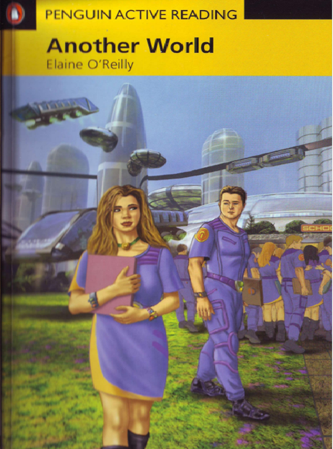

CTRL + CLICK to read and listen to the chapters of the book: https://bit.ly/2FAk7Dx
Chapter 1: https://bit.ly/316IWPu
Chapter 2: https://bit.ly/2CBXpJX
Chapter 3 https://bit.ly/2Y5zZUX
Chapter 4: https://bit.ly/316Jc0U
Chapter 5: https://bit.ly/3gerGwp
Chapter 6: https://bit.ly/2Q3a3F2
Chapter 7: https://bit.ly/3g5JNUY
Chapter 8: https://bit.ly/2E1hKsU

