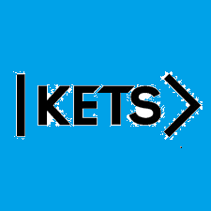
Date: August 29th –September 4th
To do:
Skills Practice 1 at: https://forms.gle/ijdfL2MRMD35gXdJ9
Listening 1 at: https://forms.gle/hBbK5MbgFzXrVZQu7

