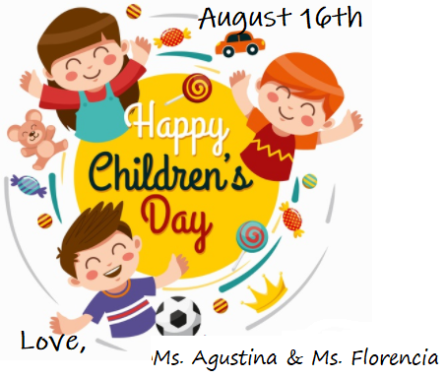

**CTRL + CLICK HERE**

[**https://forms.gle/bgDQNjov1nqL88jz6**](https://forms.gle/bgDQNjov1nqL88jz6)

**TO SEE A MESSAGE FROM YOUR TEACHERS**