We have many things to learn from you,
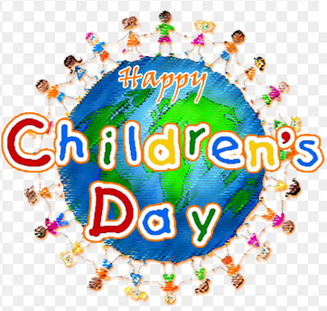
especially, how to laugh with all your hearts.

You are unique to us!
Ms. Gabriela & Ms. Micaela

A message
From
your teachers

