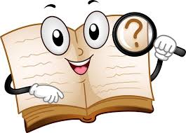
If you have doubts, use a dictionary!
There are some very good ones online.
Longman Dictionary of Contemporary English: https://www.ldoceonline.com/
Word Reference : https://www.wordreference.com/
Macmillan Dictionary: https://www.macmillandictionary.com/
Cambridge Dictionary: https://dictionary.cambridge.org/
(you can use the English-English/ English-Spanish/Thesaurus [synonyms] )

