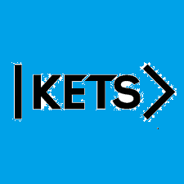
Date: November 7th –November 13th
To do:
Skills Practice 10 at: https://forms.gle/k94jKjvQ8Hx5utvW7
Listening 10 at: https://forms.gle/vyALCa5n2kiTDrUZ6

