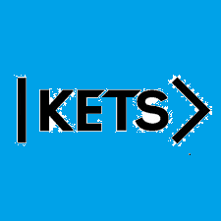
Date: November 14th –November 20th
To do:
Skills Practice 11 at: https://forms.gle/AtN5ZvYze3jxWoYG8
Listening 11 at: https://forms.gle/SYE7FuA4SGL7AencA

