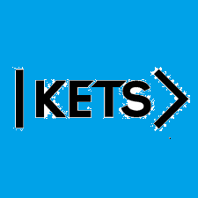
Date: September 19th –September 25th
To do:
Skills Practice 4 at:
https://forms.gle/EA48Z1Au11eDEQKL8
Listening 4 at:
https://forms.gle/ZRFrxtnUuWsX6nGL7

