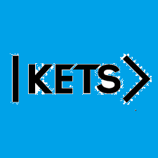
Date: September 26th –October 2nd
To do:
Skills Practice 5 at:
https://forms.gle/fSrbGHjECuxXdFda6
Listening 5 at:
https://forms.gle/Fh6rVXK5ybYoipnv7

