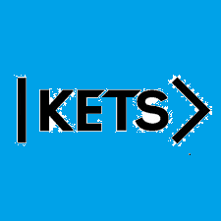
Date: October 3rd –October 9th
To do:
Skills Practice 6 at:
https://forms.gle/cxSsoPryvyPtPMvZA
Listening 6 at: https://forms.gle/dMuu5cjJVrCernWB8

