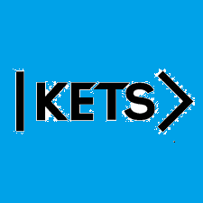
Date: October 10th –October 23rd
To do:
Skills Practice 7 at:
https://forms.gle/HcSwZqJWSopcE3zR8
Listening 7 at: https://forms.gle/AoSre7B3jLRemkh39

