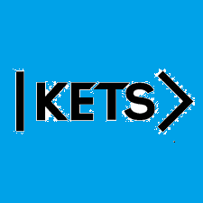
Date: October 24th –October 30th
To do:
Skills Practice 8 at: https://forms.gle/UcKBnrGCw5QPsLKW8
Listening 8 at: https://forms.gle/pkZi1u5KB1CVH4uR8

