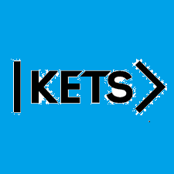
Date: October 31st –November 6th
To do:
Skills Practice 9 at: https://forms.gle/zeaBLnDfqqvKKnN67
Listening 9 at: https://forms.gle/QUgy8dLUJxEoLFZv8

