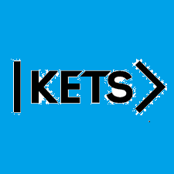
Date: September 12th –September 18th
To do:
Skills Practice 3 at:
https://forms.gle/JFmVUXvuVwjMq2jP8
Listening 3 at: https://forms.gle/jn6iQ1YFTwaN11vM7

