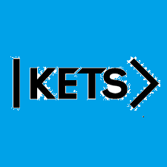
Date: September 4th –September 11th
To do:
Skills Practice 2 at:
https://forms.gle/SKa1v6ZGFY4WAFr17
Listening 2 at: https://forms.gle/NUZ968qJcdrkutmUA

