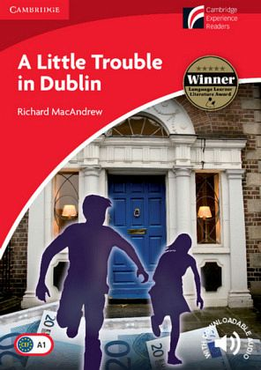
Download the material from:
PDF file: https://bit.ly/3czAvQ0
Audio files: https://bit.ly/2YSIZxW

