Name:… Surname: …
PEARSON PORTAL
6th form- GOLD EXPERIENCE A+, ONLINE PRACTICE
Module 0 – Writing tasks
Activity 10: Getting ready to write a post! Read the example below and plan your ideas. (Just think about them, don’t write anything yet)
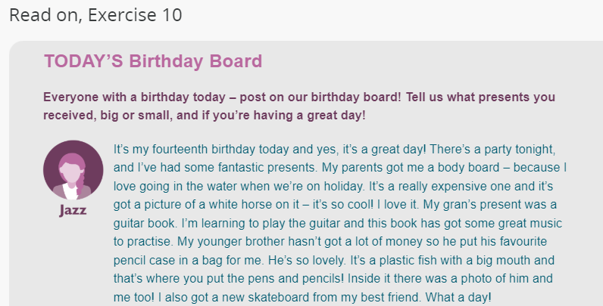
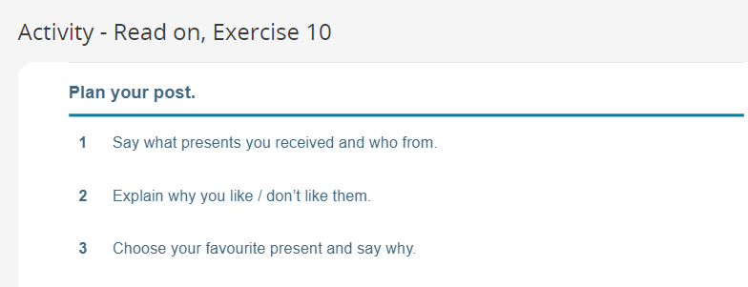

Activity 11: Now, write your post
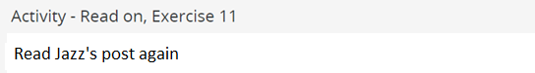
…
This is the end of your file. Check you have solved all the activities, save your work and send it to your teacher via email:
6th boys and girls:
cgarro@losrobles.esc.edu.ar

