Name:… Surname: …
PEARSON PORTAL
6th form- GOLD EXPERIENCE A+, ONLINE PRACTICE

Module 0 – Writing tasks
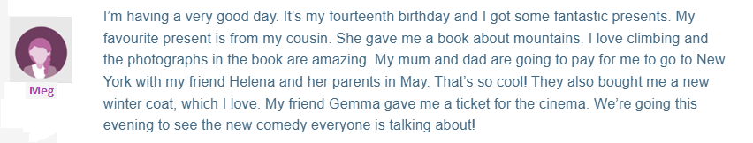
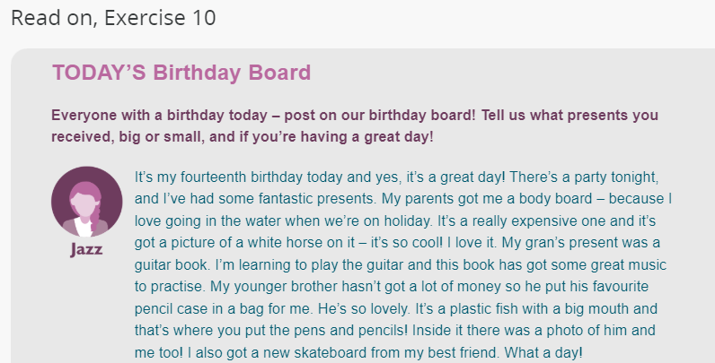
Activity 10: Getting ready to write a post! Read the examples below and plan your ideas.

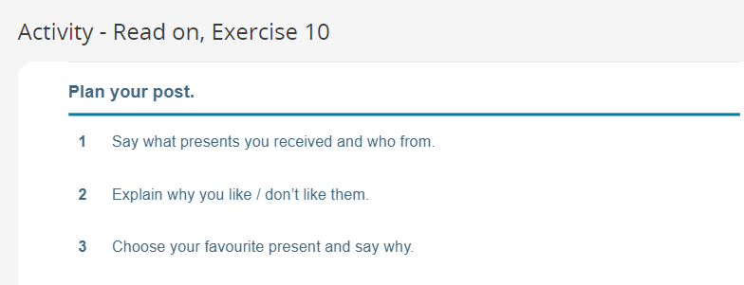
(Just think about them, don’t write anything yet.)

Activity 11: Now, write your post. You can use Jazz’s and Meg’s models.

…
This is the end of your file. Check you have solved all the activities, save your work and send it to your teacher via email:
6th boys and girls:
cgarro@losrobles.esc.edu.ar

