PICTURE DESCRIPTION USEFUL LANGUAGE
GIVE A GENERAL INTRODUCTION
'This picture shows …' 'In this picture I can see...' 'This is a picture of …'

TALK ABOUT PLACES
'They’re walking in the country/in a city/in the mountains'
'She’s talking inside/outside a cafe' or 'I can see a street market/old building/square/ street/restaurant/beach …'

DESCRIBE PEOPLE’S AGE
'He’s about 40 years old' 'They’re in their eighties'
'She’s a teenager/a young child/a middle-aged woman'

DESCRIBE PEOPLE’S CLOTHES
'She’s wearing a pair of glasses and a blue T-shirt' 'They’re wearing quite casual/smart clothes'
'He’s wearing a school/work uniform'

DESCRIBE PEOPLE’S ACTIONS
'He’s sitting at a desk/table' 'She’s standing in a queue/line'
'They’re having breakfast/lunch/dinner'
'Some people are playing on the beach and others are sunbathing’

DESCRIBE PEOPLE’S ROLES IN A PICTURE
'He’s probably a shop assistant and she could be a customer'
'This person on the left seems to be a tourist guide – he’s pointing to a building'
'The man serving the drinks is a waiter'

DESCRIBE PEOPLE’S FEELINGS IN A PICTURE
'You can tell they are enjoying themselves because they are smiling' 'He seems a bit frightened. Maybe this is the first time he’s tried this'
'She looks very interested in this activity – she’s concentrating very hard'

PARAPHRASE (use these phrases to describe words you don’t know) 'It’s something you fry food in' (frying pan)
'It’s a kind of container for flowers' (a vase)
'It’s a cupboard for keeping clothes in' (a wardrobe).

MAKE GUESSES
'It might be summer because some people are wearing sunglasses' 'They are probably in the countryside, because'
'This picture could be in Northern Europe because of the buildings'

IMPORTANT TO REMEMBER!
- Start with a general idea of the subject of the picture before going into details.
- Talk making sentences – don’t produce lists of items you can see
- Use the Present Continuous to explain what is happening.
- Organize your description – don’t describe the same thing more than once.
- Give reasons (related to the picture) for your ideas
- Talk about the situation as well as the physical things you can see in the picture.
- Give some personal reaction to the picture.
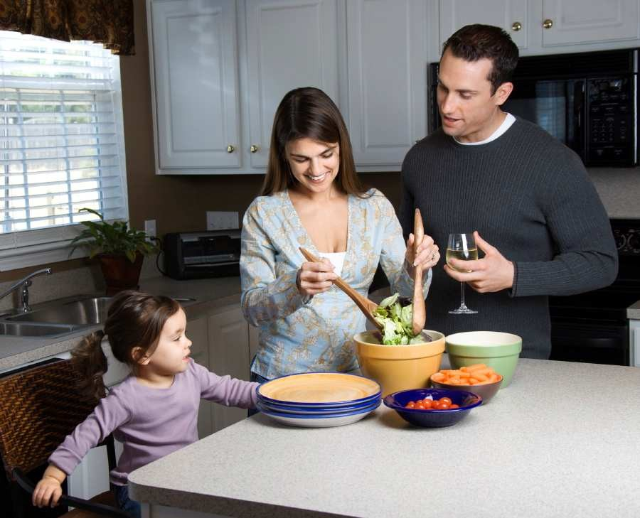
- Listen quietly when your partner describes his/her photo – don’t give help or comment

HOW TO DESCRIBE POSITION
'In the middle of the picture there is a family making a salad …'
'In the background there are some white cupboards'
'There’s a window next to the cupboards.‘

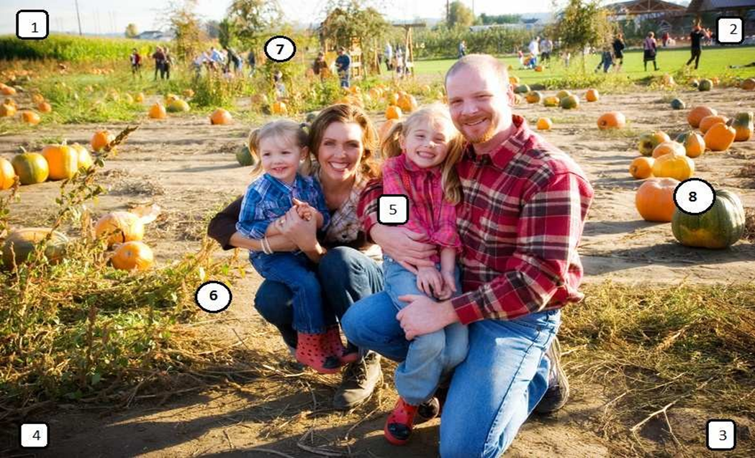

PICTURE DIRRECTIONS
- ‘In the top left corner …’
- ‘In the top right corner…’
- ‘In the bottom right corner…’
- ‘In the bottom left corner…’
- ‘In the middle …’
- ‘In the foreground…’
- ‘In the background…’
- ‘In the middle on the right…’

