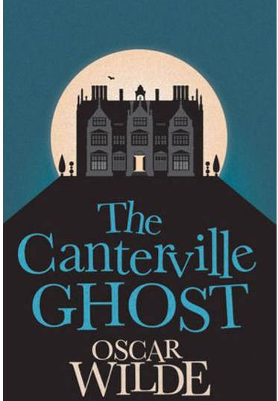

CTRL + CLICK to read and listen to the chapters of the book:
https://bit.ly/32icY2t

Part 1: https://bit.ly/32h3Pa3
Part 2: https://bit.ly/3aN8Lrg
Part 3: https://bit.ly/2FF4E4Y
Part 4: https://bit.ly/2E8myNk
Part 5: https://bit.ly/32f8HN1
Part 6: https://bit.ly/2QkZPzL

