Vocabulary units 5-6

Vocabulary 1: Weights and measures
https://forms.gle/GCwMbEVoh1uXCVZZ6
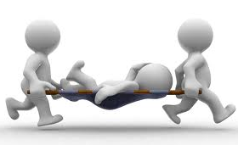
Vocabulary 2: At a restaurant
https://forms.gle/noDSqQBiuEnsAmmd7
Vocabulary 3: Accidents and injuries
https://forms.gle/ez3ywkwbUr4AgXfG8
Vocabulary 4: Types of art
https://forms.gle/iZDCy7nR86xNmT679

