Vocabulary units 7-11

Vocabulary 1: Houses
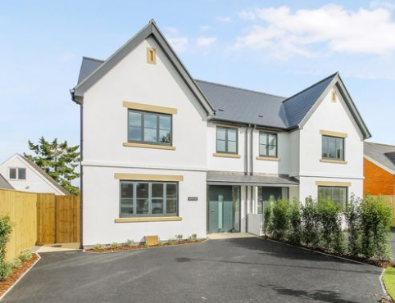
https://forms.gle/dPFS4z5hbSQH5KKYA
Vocabulary 2: Social Issues
https://forms.gle/MxYz4JjN7z4y4A5DA
Vocabulary 3: Music
https://forms.gle/fWoASSBBP3SH8bVu9
